**DEPARTMENT OF CSE - ARTIFICIAL INTELLIGENCE & MACHINE LEARNING**

**III B Tech I Sem**

**MACHINE LEARNING LAB**

Experiment-1:Implement and demonstrate the FIND-S algorithm for finding the most specific hypothesis based on a given set of training data samples. Read the training data from a .CSV file.

Experiment-2: For a given set of training data examples stored in a .CSV file, implement and demonstrate the Candidate- Elimination algorithm to output a description of the set of all hypotheses consistent with the training examples.

Experiment-3:Write a program to demonstrate the working of the decision tree based ID3 algorithm. Use an appropriate data set for building the decision tree and apply this knowledge to classify a new sample.

Experiment-4:Exercises to solve the real-world problems using the following machine learning methods: a) LinearRegression b) Logistic Regression c) Binary Classifier

Experiment-5: Develop a program for Bias, Variance, Remove duplicates , Cross Validation

Experiment-6: Write a program to implement Categorical Encoding, One-hot Encoding

Experiment-7:Build an Artificial Neural Network by implementing the Back propagation algorithm and test the same

using appropriate data sets.

Experiment-8:Write a program to implement k-Nearest Neighbor algorithm to classify the iris data set. Print both correctand wrong predictions.

Experiment-9: Implement the non-parametric Locally Weighted Regression algorithm in order to fit data

Experiment-10:Assuming a set of documents that need to be classified, use the naïve Bayesian Classifier model to perform his task. Built-in Java classes/API can be used to write the program. Calculate the accuracy, precision, andrecall for your data set.

Experiment-11: Apply EM algorithm to cluster a Heart Disease Data Set. Use the same data set forclustering using k-Means algorithm. Compare the results of these two algorithms and comment on thequality of clustering. You can add Java/Python ML library classes/API in the program.

Experiment-12: Exploratory Data Analysis for Classification using Pandas or Matplotlib.

Experiment-13:Write a Python program to construct a Bayesian network considering medical data. Use this model to demonstrate the diagnosis of heart patients using standard Heart Disease Data Set

Experiment-14: Write a program to Implement Support Vector Machines and Principle Component Analysis

Experiment-15: Write a program to Implement Principle Component Analysis

**Experiment-1**

**Aim:**Implement and demonstrate the FIND-S algorithm for finding the most specific hypothesis based on a given set of training data samples. Read the training data from a .CSV file.

Program code:

import csv

a = []

with open('1.csv', 'r') as csvfile:

for row in csv.reader(csvfile):

a.append(row)

print(a)

print("\n The total number of training instances are : ",len(a))

num_attribute = len(a[0])-1

hypothesis = ['0']*num_attribute

print("\n The initial hypothesis is : \n", hypothesis)

for i in range(0, len(a)):

if a[i][num_attribute] == 'yes':

for j in range(0, num_attribute):

if hypothesis[j] == '0' or hypothesis[j] == a[i][j]:

hypothesis[j] = a[i][j]

else:

hypothesis[j] = '?'

print("\n The hypothesis for the training instance {} is: \n" .format(i+1),hypothesis)

print("\n The Maximally specific hypothesis for the training instances is: \n",hypothesis )

OUTPUT:

[['sunny', 'warm', 'normal', 'strong', 'warm', 'same', 'yes'], ['sunny', 'warm', 'high', 'strong', 'warm', 'same', 'yes'],

['rainy', 'cold', 'high', 'strong', 'warm', 'change', 'no'], ['sunny', 'warm', 'high', 'strong', 'cool', 'change', 'yes']]

The total number of training instances are : 4

The initial hypothesis is :

['0', '0', '0', '0', '0', '0']

The hypothesis for the training instance 1 is:

['sunny', 'warm', 'normal', 'strong', 'warm', 'same']

The hypothesis for the training instance 2 is:

['sunny', 'warm', '?', 'strong', 'warm', 'same']

The hypothesis for the training instance 3 is:

['sunny', 'warm', '?', 'strong', 'warm', 'same']

The hypothesis for the training instance 4 is:

['sunny', 'warm', '?', 'strong', '?', '?']

The Maximally specific hypothesis for the training instances is:

['sunny', 'warm', '?', 'strong', '?', '?']

**EXPERIMENT-2**

**Aim**: For a given set of training data examples stored in a .CSV file, implement and demonstrate the Candidate- Elimination algorithm to output a description of the set of all hypotheses consistent with the training examples

Program code:

import csv

with open("trainingexamples.csv") as f:

csv_file = csv.reader(f)

data = list(csv_file)

specific = data[1][:-1]

general = [['?' for i in range(len(specific))] for j in range(len(specific))]

for i in data:

if i[-1] == "Yes":

for j in range(len(specific)):

if i[j] != specific[j]:

specific[j] = "?"

general[j][j] = "?"

elif i[-1] == "No":

for j in range(len(specific)):

if i[j] != specific[j]:

general[j][j] = specific[j]

else:

general[j][j] = "?"

print("\nStep " + str(data.index(i)+1) + " of Candidate Elimination Algorithm")

print(specific)

print(general)

gh = [] # gh = general Hypothesis

for i in general:

for j in i:

if j != '?':

gh.append(i)

break

print("\nFinal Specific hypothesis:\n", specific)

print("\nFinal General hypothesis:\n", gh)

OUTPUT: Step 1 of Candidate Elimination Algorithm

['Sunny', 'Warm', 'Normal', 'Strong', 'Warm', 'Same']

[['?', '?', '?', '?', '?', '?'], ['?', '?', '?', '?', '?', '?'], ['?', '?', '?', '?', '?', '?'], ['?', '?', '?', '?', '?', '?'], ['?', '?', '?', '?', '?', '?'], ['?', '?', '?', '?', '?', '?']]

Step 2 of Candidate Elimination Algorithm

['Sunny', 'Warm', 'Normal', 'Strong', 'Warm', 'Same']

[['?', '?', '?', '?', '?', '?'], ['?', '?', '?', '?', '?', '?'], ['?', '?', '?', '?', '?', '?'], ['?', '?', '?', '?', '?', '?'], ['?', '?', '?', '?', '?', '?'], ['?', '?', '?', '?', '?', '?']]

Step 3 of Candidate Elimination Algorithm

['Sunny', 'Warm', '?', 'Strong', 'Warm', 'Same']

[['?', '?', '?', '?', '?', '?'], ['?', '?', '?', '?', '?', '?'], ['?', '?', '?', '?', '?', '?'], ['?', '?', '?', '?', '?', '?'], ['?', '?', '?', '?', '?', '?'], ['?', '?', '?', '?', '?', '?']]

Step 4 of Candidate Elimination Algorithm

['Sunny', 'Warm', '?', 'Strong', 'Warm', 'Same']

[['Sunny', '?', '?', '?', '?', '?'], ['?', 'Warm', '?', '?', '?', '?'], ['?', '?', '?', '?', '?', '?'], ['?', '?', '?', '?', '?', '?'], ['?', '?', '?', '?', '?', '?'], ['?', '?', '?', '?', '?', 'Same']]

Step 5 of Candidate Elimination Algorithm

['Sunny', 'Warm', '?', 'Strong', '?', '?']

[['Sunny', '?', '?', '?', '?', '?'], ['?', 'Warm', '?', '?', '?', '?'], ['?', '?', '?', '?', '?', '?'], ['?', '?', '?', '?', '?', '?'], ['?', '?', '?', '?', '?', '?'], ['?', '?', '?', '?', '?', '?']]

Final Specific hypothesis:

['Sunny', 'Warm', '?', 'Strong', '?', '?']

Final General hypothesis:

[['Sunny', '?', '?', '?', '?', '?'], ['?', 'Warm', '?', '?', '?', '?']]

**EXPERIMENT-3**

**Aim** :Write a program to demonstrate the working of the decision tree based ID3 algorithm. Use an appropriate data set for building the decision tree and apply this knowledge to classify a new sample.

Program code:

import numpy as np

import math

import csv

def read_data(filename):

with open(filename, 'r') as csvfile:

datareader = csv.reader(csvfile, delimiter=',')

headers = next(datareader)

metadata = []

traindata = []

for name in headers:

metadata.append(name)

for row in datareader:

traindata.append(row)

return (metadata, traindata)

class Node:

def __init__(self, attribute):

self.attribute = attribute

self.children = []

self.answer = ""

def __str__(self):

return self.attribute

def subtables(data, col, delete):

dict = {}

items = np.unique(data[:, col])

count = np.zeros((items.shape[0], 1), dtype=np.int32)

for x in range(items.shape[0]):

for y in range(data.shape[0]):

if data[y, col] == items[x]:

count[x] += 1

for x in range(items.shape[0]):

dict[items[x]] = np.empty((int(count[x]), data.shape[1]), dtype="|S32")

pos = 0

for y in range(data.shape[0]):

if data[y, col] == items[x]:

dict[items[x]][pos] = data[y]

pos += 1

if delete:

dict[items[x]] = np.delete(dict[items[x]], col, 1)

return items, dict

def entropy(S):

items = np.unique(S)

if items.size == 1:

return 0

counts = np.zeros((items.shape[0], 1))

sums = 0

for x in range(items.shape[0]):

counts[x] = sum(S == items[x]) / (S.size * 1.0)

for count in counts:

sums += -1 * count * math.log(count, 2)

return sums

def gain_ratio(data, col):

items, dict = subtables(data, col, delete=False)

total_size = data.shape[0]

entropies = np.zeros((items.shape[0], 1))

intrinsic = np.zeros((items.shape[0], 1))

for x in range(items.shape[0]):

ratio = dict[items[x]].shape[0]/(total_size * 1.0)

entropies[x] = ratio * entropy(dict[items[x]][:, -1])

intrinsic[x] = ratio * math.log(ratio, 2)

total_entropy = entropy(data[:, -1])

iv = -1 * sum(intrinsic)

for x in range(entropies.shape[0]):

total_entropy -= entropies[x]

return total_entropy / iv

def create_node(data, metadata):

if (np.unique(data[:, -1])).shape[0] == 1:

node = Node("")

node.answer = np.unique(data[:, -1])[0]

return node

gains = np.zeros((data.shape[1] - 1, 1))

for col in range(data.shape[1] - 1):

gains[col] = gain_ratio(data, col)

split = np.argmax(gains)

node = Node(metadata[split])

metadata = np.delete(metadata, split, 0)

items, dict = subtables(data, split, delete=True)

for x in range(items.shape[0]):

child = create_node(dict[items[x]], metadata)

node.children.append((items[x], child))

return node

def empty(size):

s = ""

for x in range(size):

s += " "

return s

def print_tree(node, level):

if node.answer != "":

print(empty(level), node.answer)

return

print(empty(level), node.attribute)

for value, n in node.children:

print(empty(level + 1), value)

print_tree(n, level + 2)

metadata, traindata = read_data("datasets.csv")

data = np.array(traindata)

node = create_node(data, metadata)

print_tree(node, 0)

OUTPUT

Day

D1

b'No'

D10

b'Yes'

D2

b'No'

D3

b'Yes'

D4

b'Yes'

D5

b'Yes'

D6

b'No'

D7

b'Yes'

D8

b'No'

D9

b'Yes'

<ipython-input-13-9006b06be895>:38: DeprecationWarning: Conversion of an array with ndim > 0 to a scalar is deprecated, and will error in future. Ensure you extract a single element from your array before performing this operation. (Deprecated NumPy 1.25.)

dict[items[x]] = np.empty((int(count[x]), data.shape[1]), dtype="|S32")

<ipython-input-13-9006b06be895>:62: DeprecationWarning: Conversion of an array with ndim > 0 to a scalar is deprecated, and will error in future. Ensure you extract a single element from your array before performing this operation. (Deprecated NumPy 1.25.)

sums += -1 * count * math.log(count, 2)

**EXPERIMENT-4**

**Aim:**

**PROGRAM**

To solve the real-world problems using the machine learning methods. Linear Regression and

Logistic Regression

Dataset: std_marks.csv-constructed on own by using students lab internal and external marks.

Program code:

import pandas as pd

from sklearn import linear_model

import matplotlib.pyplot as plt

from sklearn.metrics import mean_squared_error

from sklearn.model_selection import train_test_split

data=pd.read_csv(r"E:\sudhakar\std_marks.csv")

print('First 5 rows of the data set are:')

print(data.head())

dim=data.shape

print('Dimensions of the data set are',dim)

print('Statistics of the data are:')

print(data.describe())

print('Correlation matrix of the data set is:')

print(data.corr())

x_set=data[['internal']]

print('First 5 rows of features set are:')

print(x_set.head())

y_set=data[['external']]

print('First 5 rows of features set are:')

print(y_set.head())

x_train,x_test, y_train, y_test = train_test_split(x_set,y_set, test_size = 0.3)

model=linear_model.LinearRegression()

model.fit(x_train,y_train)

print('Regression coefficient is',float(model.coef_))

print('Regression intercept is',float(model.intercept_))

y_pred=model.predict(x_test)

y_preds=[]

for i in y_pred:

7 y_preds.append(float(i))

print('Predicted values for test data are:')

print(y_preds)

print('mean squared error is ',mean_squared_error(y_test,y_pred))

plt.scatter(x_test,y_test,color='blue',label='actual y values')

plt.plot(x_test,y_pred,color='red',linewidth=3,label='predicted regression line')

plt.ylabel('y value')

plt.xlabel('x value')

plt.title('simple linear regression')

plt.legend(loc='best')

plt.show()

Output screen shots:

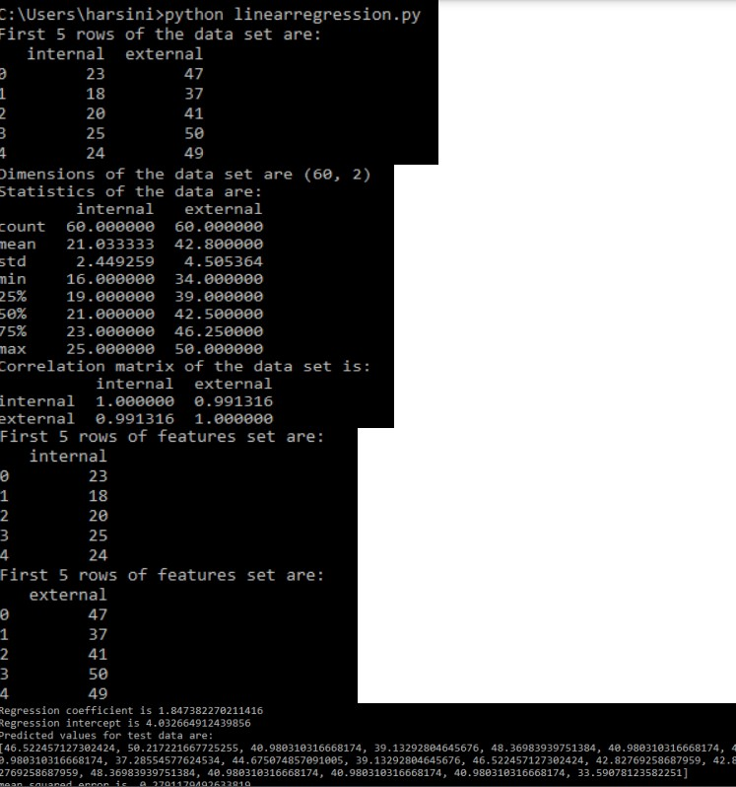

B)

import warnings

warnings.filterwarnings("ignore")

import pandas as pd

import seaborn as sns

from sklearn.model_selection import train_test_split

from sklearn.linear_model import LogisticRegression

from sklearn.metrics import confusion_matrix

from sklearn.metrics import classification_report

from sklearn.metrics import accuracy_score

from sklearn.metrics import recall_score

from sklearn.metrics import precision_score

from sklearn.preprocessing import StandardScaler

data=pd.read_csv(r"E:\sudhakar\heart.csv")

print('The first 5 rows of the data set are:')

print(data.head())

dim=data.shape

print('Dimensions of the data set are',dim)

print('Statistics of the data are:')

print(data.describe())

print('Correlation matrix of the data set is:')

print(data.corr())

class_lbls=data['target'].unique()

class_labels=[]

for x in class_lbls:

class_labels.append(str(x))

print('Class labels are:')

print(class_labels)

sns.countplot(data['target'])

col_names=data.columns

feature_names=col_names[:-1]

feature_names=list(feature_names)

print('Feature names are:')

print(feature_names)

x_set = data.drop(['target'], axis=1)

print('First 5 rows of features set are:')

print(x_set.head())

y_set=data[['target']]

print('First 5 rows of features set are:')

print(y_set.head())

scaler=StandardScaler()

x_train,x_test, y_train, y_test = train_test_split(x_set,y_set, test_size = 0.3)

scaler.fit(x_train)

x_train=scaler.transform(x_train)

model = LogisticRegression()

model.fit(x_train, y_train)

x_test=scaler.transform(x_test)

y_pred=model.predict(x_test)

print('Predicted class labels for test data are:')

print(y_pred)

print("Accuracy:",accuracy_score(y_test, y_pred))

print("Precision:",precision_score(y_test, y_pred))

print("Recall:",recall_score(y_test, y_pred))

print(classification_report(y_test,y_pred,target_names=class_labels))

cm=confusion_matrix(y_test,y_pred)

df_cm = pd.DataFrame(cm, columns=class_labels, index = class_labels)

df_cm.index.name = 'Actual'

df_cm.columns.name = 'Predicted'

sns.set(font_scale=1.5)

sns.heatmap(df_cm, annot=True,cmap="Blues",fmt='d')

OUTPUT

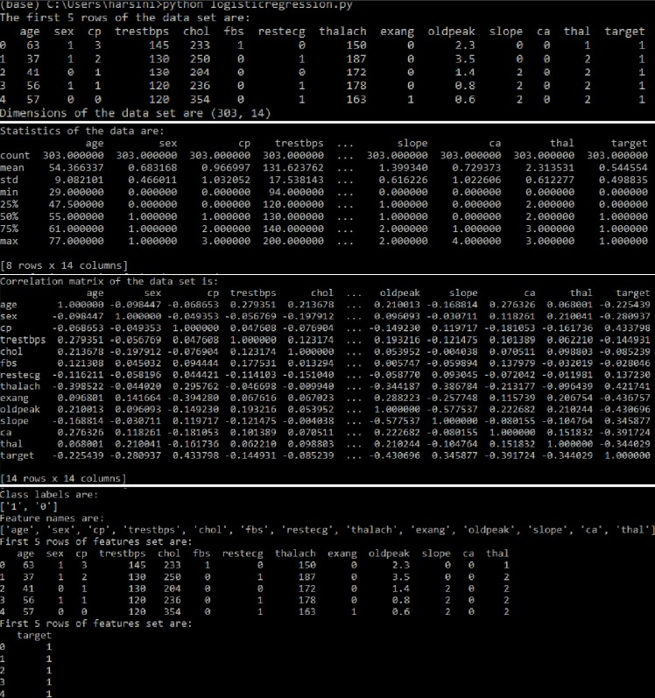

**EXPERIMENGT-5**

**Aim:** Develop a program for Bias, Variance, Remove duplicates , Cross Validation

**PROGRAM**

from pandas import read_csv

from sklearn.model_selection import train_test_split

from sklearn.linear_model import LinearRegression

from mlxtend.evaluate import bias_variance_decomp

# load dataset

url = 'https://raw.githubusercontent.com/jbrownlee/Datasets/master/housing.csv'

dataframe = read_csv(url, header=None)

# separate into inputs and outputs

data = dataframe.values

X, y = data[:, :-1], data[:, -1]

# split the data

X_train, X_test, y_train, y_test = train_test_split(X, y, test_size=0.33, random_state=1)

# define the model

model = LinearRegression()

# estimate bias and variance

mse, bias, var = bias_variance_decomp(model, X_train, y_train, X_test, y_test, loss='mse', num_rounds=200, random_seed=1)

# summarize results

print('MSE: %.3f' % mse)

print('Bias: %.3f' % bias)

print('Variance: %.3f' % var)

**OUTPUT**

MSE: 22.418

Bias: 20.744

Variance: 1.674

**EXPERIMENT-6**

**Aim;** Write a program to implement Categorical Encoding, One-hot Encoding

**PROGRAM**

import pandas as pd

# Sample categorical data

data = {'fruit': ['apple', 'orange', 'banana', 'apple']}

df = pd.DataFrame(data)

# One Hot Encoding using Pandas get_dummies

encoded_df = pd.get_dummies(df, columns=['fruit'])

print(encoded_df)

**OUTPUT**

fruit_apple fruit_banana fruit_orange

0 True False False

1 False False True

2 False True False

3 True False False

**Experiment -7**

**Aim**: To build ANN by implementing the back propogation algorithm and test the same using appropriate datasets

Program code:

import numpy as np

import matplotlib.pyplot as plt

# Define the sigmoid activation function and its derivative

def sigmoid(x):

return 1 / (1 + np.exp(-x))

def sigmoid_derivative(x):

return x * (1 - x)

# XOR dataset

X = np.array([[0, 0], [0, 1], [1, 0], [1, 1]])

y = np.array([[0], [1], [1], [0]])

# Neural network architecture

input_size = 2

hidden_size = 4

output_size = 1

# Initialize weights and biases

weights_input_hidden = np.random.rand(input_size, hidden_size)

bias_hidden = np.zeros((1, hidden_size))

weights_hidden_output = np.random.rand(hidden_size, output_size)

bias_output = np.zeros((1, output_size))

# Training parameters

epochs = 10000

learning_rate = 0.1

# Lists to store loss values for visualization

loss_history = []

# Training loop

for epoch in range(epochs):

# Forward pass

hidden_layer_input = np.dot(X, weights_input_hidden) + bias_hidden

hidden_layer_output = sigmoid(hidden_layer_input)

output_layer_input = np.dot(hidden_layer_output, weights_hidden_output) + bias_output

output_layer_output = sigmoid(output_layer_input)

# Calculate loss

loss = np.mean(np.square(y - output_layer_output))

loss_history.append(loss)

# Backpropagation

output_delta = (y - output_layer_output) * sigmoid_derivative(output_layer_output)

hidden_layer_loss = output_delta.dot(weights_hidden_output.T)

hidden_layer_delta = hidden_layer_loss * sigmoid_derivative(hidden_layer_output)

# Update weights and biases

weights_hidden_output += hidden_layer_output.T.dot(output_delta) * learning_rate

bias_output += np.sum(output_delta, axis=0, keepdims=True) * learning_rate

weights_input_hidden += X.T.dot(hidden_layer_delta) * learning_rate

bias_hidden += np.sum(hidden_layer_delta, axis=0, keepdims=True) * learning_rate

# Test the trained neural network

test_input = np.array([[0, 0], [0, 1], [1, 0], [1, 1]])

predictions = sigmoid(np.dot(sigmoid(np.dot(test_input, weights_input_hidden) + bias_hidden), weights_hidden_output) + bias_output)

print(predictions)

# Visualize the training loss

plt.plot(range(epochs), loss_history)

plt.xlabel('Epochs')

plt.ylabel('Loss')

plt.title('Training Loss')

plt.show()

**EXPERIMENT-8**

**Aim:**Write a program to implement k-Nearest Neighbor algorithm to classify the iris data set. Print both correct and wrong predictions.

Program Code:

# Import necessary libraries

from sklearn import datasets

from sklearn.model_selection import train_test_split

from sklearn.neighbors import KNeighborsClassifier

from sklearn.metrics import accuracy_score

# Load the Iris dataset

iris = datasets.load_iris()

X = iris.data

y = iris.target

# Split the dataset into training and testing sets

X_train, X_test, y_train, y_test = train_test_split(X, y, test_size=0.3, random_state=42)

# Initialize the k-NN classifier with a specified k value (e.g., k=3)

knn = KNeighborsClassifier(n_neighbors=3)

# Fit the classifier to the training data

knn.fit(X_train, y_train)

# Make predictions on the test data

y_pred = knn.predict(X_test)

# Print correct and wrong predictions

correct_predictions = 0

wrong_predictions = 0

for i in range(len(y_test)):

if y_pred[i] == y_test[i]:

print(f"Correct Prediction: Actual Class {y_test[i]}, Predicted Class {y_pred[i]}")

correct_predictions += 1

else:

print(f"Wrong Prediction: Actual Class {y_test[i]}, Predicted Class {y_pred[i]}")

wrong_predictions += 1

# Calculate and print the accuracy of the k-NN classifier

accuracy = accuracy_score(y_test, y_pred)

print(f"Accuracy: {accuracy * 100:.2f}%")

print(f"Correct Predictions: {correct_predictions}")

print(f"Wrong Predictions: {wrong_predictions}")

Output:

Correct Prediction: Actual Class 1, Predicted Class 1

Correct Prediction: Actual Class 0, Predicted Class 0

Correct Prediction: Actual Class 2, Predicted Class 2

Correct Prediction: Actual Class 1, Predicted Class 1

Correct Prediction: Actual Class 1, Predicted Class 1

Correct Prediction: Actual Class 0, Predicted Class 0

Correct Prediction: Actual Class 1, Predicted Class 1

Correct Prediction: Actual Class 2, Predicted Class 2

Correct Prediction: Actual Class 1, Predicted Class 1

Correct Prediction: Actual Class 1, Predicted Class 1

Correct Prediction: Actual Class 2, Predicted Class 2

Correct Prediction: Actual Class 0, Predicted Class 0

Correct Prediction: Actual Class 0, Predicted Class 0

Correct Prediction: Actual Class 0, Predicted Class 0

Correct Prediction: Actual Class 0, Predicted Class 0

Correct Prediction: Actual Class 1, Predicted Class 1

Correct Prediction: Actual Class 2, Predicted Class 2

Correct Prediction: Actual Class 1, Predicted Class 1

Correct Prediction: Actual Class 1, Predicted Class 1

Correct Prediction: Actual Class 2, Predicted Class 2

Correct Prediction: Actual Class 0, Predicted Class 0

Correct Prediction: Actual Class 2, Predicted Class 2

Correct Prediction: Actual Class 0, Predicted Class 0

Correct Prediction: Actual Class 2, Predicted Class 2

Correct Prediction: Actual Class 2, Predicted Class 2

Correct Prediction: Actual Class 2, Predicted Class 2

Correct Prediction: Actual Class 2, Predicted Class 2

Correct Prediction: Actual Class 2, Predicted Class 2

Correct Prediction: Actual Class 0, Predicted Class 0

Correct Prediction: Actual Class 0, Predicted Class 0

Correct Prediction: Actual Class 0, Predicted Class 0

Correct Prediction: Actual Class 0, Predicted Class 0

Correct Prediction: Actual Class 1, Predicted Class 1

Correct Prediction: Actual Class 0, Predicted Class 0

Correct Prediction: Actual Class 0, Predicted Class 0

Correct Prediction: Actual Class 2, Predicted Class 2

Correct Prediction: Actual Class 1, Predicted Class 1

Correct Prediction: Actual Class 0, Predicted Class 0

Correct Prediction: Actual Class 0, Predicted Class 0

Correct Prediction: Actual Class 0, Predicted Class 0

Correct Prediction: Actual Class 2, Predicted Class 2

Correct Prediction: Actual Class 1, Predicted Class 1

Correct Prediction: Actual Class 1, Predicted Class 1

Correct Prediction: Actual Class 0, Predicted Class 0

Correct Prediction: Actual Class 0, Predicted Class 0

Accuracy: 100.00%

Correct Predictions: 45

Wrong Predictions: 0

**EXPERIMENT -9**

**Aim:**To implement non-parametric locally weighted regression are in order to figure the data points select appropriate dataset

Program Code:

import numpy as np

import matplotlib.pyplot as plt

# Generate synthetic data (sine wave with noise)

np.random.seed(0)

X = np.sort(5 * np.random.rand(80, 1), axis=0)

y = np.sin(X).ravel() + np.random.rand(80)

def locally_weighted_regression(test_point, X, y, tau):

    m, n = X.shape

    weights = np.zeros((m, m))

    for i in range(m):

        xi = X[i]

        weights[i, i] = np.exp(-((test_point - xi) ** 2) / (2 * tau ** 2))

    theta = np.linalg.pinv(X.T @ (weights @ X)) @ (X.T @ (weights @ y))

    return test_point * theta

# Predict for a set of test points

tau = 0.1  # Bandwidth parameter

X_test = np.linspace(0, 5, 100)

y_pred = [locally_weighted_regression(test_point, X, y, tau) for test_point in X_test]

# Plot the data and predictions

plt.scatter(X, y, c='r', label='Data points')

plt.plot(X_test, y_pred, c='b', label='LWR Predictions')

plt.xlabel('X')

plt.ylabel('y')

plt.legend()

plt.show()

**Experiment-10:**

**Aim:**Assuming a set of documents that need to be classified, use the naïve Bayesian Classifier model to perform this task. Built-in Java classes/API can be used to write the program. Calculate the accuracy, precision, and recall for your data set.

Program code:

from sklearn.datasets import fetch_20newsgroups

from sklearn.model_selection import train_test_split

from sklearn.feature_extraction.text import CountVectorizer

from sklearn.naive_bayes import MultinomialNB

from sklearn import metrics

# Load the 20 newsgroups dataset

newsgroups = fetch_20newsgroups(subset='all', remove=('headers', 'footers', 'quotes'))

# Split the dataset into training and testing sets

X_train, X_test, y_train, y_test = train_test_split(newsgroups.data, newsgroups.target, test_size=0.2, random_state=42)

# Vectorize the text data

vectorizer = CountVectorizer()

X_train_vec = vectorizer.fit_transform(X_train)

X_test_vec = vectorizer.transform(X_test)

# Train the Naive Bayes Classifier

nb_classifier = MultinomialNB()

nb_classifier.fit(X_train_vec, y_train)

# Make predictions

y_pred = nb_classifier.predict(X_test_vec)

# Calculate Accuracy, Precision, and Recall

accuracy = metrics.accuracy_score(y_test, y_pred)

precision = metrics.precision_score(y_test, y_pred, average='weighted')

recall = metrics.recall_score(y_test, y_pred, average='weighted')

# Print the results

print(f"Accuracy: {accuracy:.4f}")

print(f"Precision: {precision:.4f}")

print(f"Recall: {recall:.4f}")

Output:

Accuracy: 0.6175

Precision: 0.6960

Recall: 0.6175

EXPERIMENT-11

Aim:

Program code: from sklearn.cluster import KMeans

from sklearn.mixture import GaussianMixture

import sklearn.metrics as metrics

import pandas as pd

import numpy as np

import matplotlib.pyplot as plt

names = ['Sepal_Length','Sepal_Width','Petal_Length','Petal_Width', 'Class']

dataset = pd.read_csv("8-dataset.csv", names=names)

X = dataset.iloc[:, :-1]

label = {'Iris-setosa': 0,'Iris-versicolor': 1, 'Iris-virginica': 2}

y = [label[c] for c in dataset.iloc[:, -1]]

plt.figure(figsize=(14,7))

colormap=np.array(['red','lime','black'])

# REAL PLOT

plt.subplot(1,3,1)

plt.title('Real')

plt.scatter(X.Petal_Length,X.Petal_Width,c=colormap[y])

# K-PLOT

model=KMeans(n_clusters=3, random_state=0).fit(X)

plt.subplot(1,3,2)

plt.title('KMeans')

plt.scatter(X.Petal_Length,X.Petal_Width,c=colormap[model.labels_])

print('The accuracy score of K-Mean: ',metrics.accuracy_score(y, model.labels_))

print('The Confusion matrixof K-Mean:\n',metrics.confusion_matrix(y, model.labels_))

# GMM PLOT

gmm=GaussianMixture(n_components=3, random_state=0).fit(X)

y_cluster_gmm=gmm.predict(X)

plt.subplot(1,3,3)

plt.title('GMM Classification')

plt.scatter(X.Petal_Length,X.Petal_Width,c=colormap[y_cluster_gmm])

print('The accuracy score of EM: ',metrics.accuracy_score(y, y_cluster_gmm))

print('The Confusion matrix of EM:\n ',metrics.confusion_matrix(y, y_cluster_gmm))

Output

The accuracy score of K-Mean: 0.24

The Confusion matrixof K-Mean:

[[ 0 50 0]

[48 0 2]

[14 0 36]]

The accuracy score of EM: 0.36666666666666664

The Confusion matrix of EM:

[[50 0 0]

[ 0 5 45]

[ 0 50 0]]

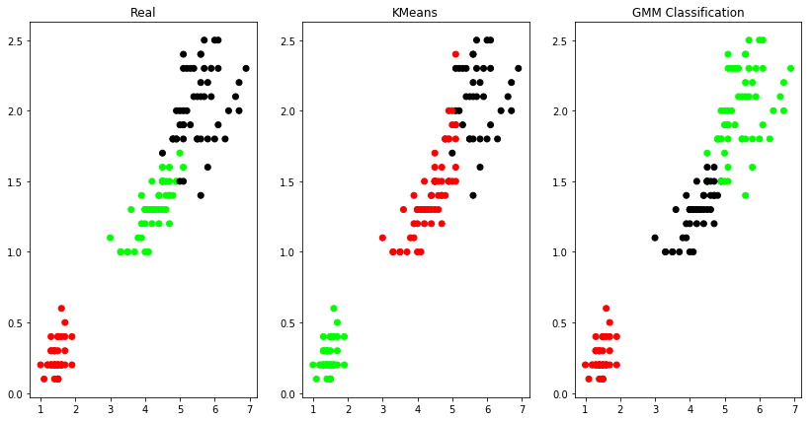

**EXPERIMENT-12**

**Aim:** Exploratory Data Analysis for Classification using Pandas or Matplotlib.

Program code:

import pandas as pd

import matplotlib.pyplot as plt

import seaborn as sns

# Load the Heart Disease Data Set

url = "https://archive.ics.uci.edu/ml/machine-learning-databases/heart-disease/processed.cleveland.data"

column_names = ["age", "sex", "cp", "trestbps", "chol", "fbs", "restecg", "thalach", "exang", "oldpeak", "slope", "ca", "thal", "target"]

heart_data = pd.read_csv(url, header=None, names=column_names, na_values="?")

# Display the first few rows of the dataset

print(heart_data.head())

# Summary statistics of numerical features

print(heart_data.describe())

# Info about the dataset, including data types and missing values

print(heart_data.info())

# Distribution of the target variable

sns.countplot(x='target', data=heart_data)

plt.title('Distribution of Target Variable')

plt.show()

# Pairplot to visualize relationships between numerical features

sns.pairplot(heart_data, hue='target')

plt.suptitle('Pairplot of Numerical Features', y=1.02)

plt.show()

# Correlation heatmap to check for feature correlations

corr_matrix = heart_data.corr()

plt.figure(figsize=(12, 8))

sns.heatmap(corr_matrix, annot=True, cmap='coolwarm', fmt=".2f")

plt.title('Correlation Heatmap')

plt.show()

# Boxplots for individual features

features = ["age", "trestbps", "chol", "thalach", "oldpeak"] # Select a subset of features

for feature in features:

sns.boxplot(x='target', y=feature, data=heart_data)

plt.title(f'Boxplot of {feature} by Target')

plt.show()

Output:

age sex cp trestbps chol fbs restecg thalach exang oldpeak \

0 63.0 1.0 1.0 145.0 233.0 1.0 2.0 150.0 0.0 2.3

1 67.0 1.0 4.0 160.0 286.0 0.0 2.0 108.0 1.0 1.5

2 67.0 1.0 4.0 120.0 229.0 0.0 2.0 129.0 1.0 2.6

3 37.0 1.0 3.0 130.0 250.0 0.0 0.0 187.0 0.0 3.5

4 41.0 0.0 2.0 130.0 204.0 0.0 2.0 172.0 0.0 1.4

slope ca thal target

0 3.0 0.0 6.0 0

1 2.0 3.0 3.0 2

2 2.0 2.0 7.0 1

3 3.0 0.0 3.0 0

4 1.0 0.0 3.0 0

age sex cp trestbps chol fbs \

count 303.000000 303.000000 303.000000 303.000000 303.000000 303.000000

mean 54.438944 0.679868 3.158416 131.689769 246.693069 0.148515

std 9.038662 0.467299 0.960126 17.599748 51.776918 0.356198

min 29.000000 0.000000 1.000000 94.000000 126.000000 0.000000

25% 48.000000 0.000000 3.000000 120.000000 211.000000 0.000000

50% 56.000000 1.000000 3.000000 130.000000 241.000000 0.000000

75% 61.000000 1.000000 4.000000 140.000000 275.000000 0.000000

max 77.000000 1.000000 4.000000 200.000000 564.000000 1.000000

restecg thalach exang oldpeak slope ca \

count 303.000000 303.000000 303.000000 303.000000 303.000000 299.000000

mean 0.990099 149.607261 0.326733 1.039604 1.600660 0.672241

std 0.994971 22.875003 0.469794 1.161075 0.616226 0.937438

min 0.000000 71.000000 0.000000 0.000000 1.000000 0.000000

25% 0.000000 133.500000 0.000000 0.000000 1.000000 0.000000

50% 1.000000 153.000000 0.000000 0.800000 2.000000 0.000000

75% 2.000000 166.000000 1.000000 1.600000 2.000000 1.000000

max 2.000000 202.000000 1.000000 6.200000 3.000000 3.000000

thal target

count 301.000000 303.000000

mean 4.734219 0.937294

std 1.939706 1.228536

min 3.000000 0.000000

25% 3.000000 0.000000

50% 3.000000 0.000000

75% 7.000000 2.000000

max 7.000000 4.000000

<class 'pandas.core.frame.DataFrame'>

RangeIndex: 303 entries, 0 to 302

Data columns (total 14 columns):

# Column Non-Null Count Dtype

--- ------ -------------- -----

0 age 303 non-null float64

1 sex 303 non-null float64

2 cp 303 non-null float64

3 trestbps 303 non-null float64

4 chol 303 non-null float64

5 fbs 303 non-null float64

6 restecg 303 non-null float64

7 thalach 303 non-null float64

8 exang 303 non-null float64

9 oldpeak 303 non-null float64

10 slope 303 non-null float64

11 ca 299 non-null float64

12 thal 301 non-null float64

13 target 303 non-null int64

dtypes: float64(13), int64(1)

memory usage: 33.3 KB

None

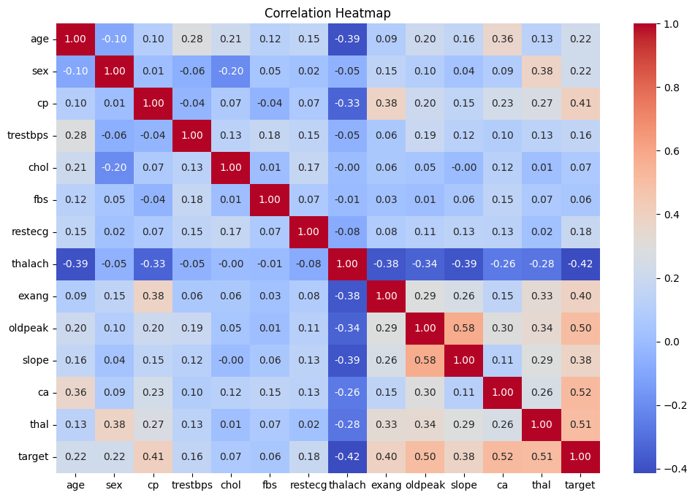

**EXPERIMENT-13**

**Aim:** Write a Python program to construct a Bayesian network considering medical data. Use this model to demonstrate the diagnosis of heart patients using standard Heart Disease Data Set

**Program code:**

**EXPERIMENT-14**

**Aim:**Write a program to Implement Support Vector Machines and Principle Component Analysis

Program code:

import numpy as np

import matplotlib.pyplot as plt

from sklearn import datasets

from sklearn.model_selection import train_test_split

from sklearn.preprocessing import StandardScaler

from sklearn.decomposition import PCA

from sklearn.svm import SVC

from sklearn.metrics import accuracy_score

# Load a sample dataset (Iris dataset)

data = datasets.load_iris()

X = data.data

y = data.target

# Split the data into training and testing sets

X_train, X_test, y_train, y_test = train_test_split(X, y, test_size=0.3, random_state=42)

# Step 1: Standardize the data (mean=0, variance=1)

scaler = StandardScaler()

X_train_std = scaler.fit_transform(X_train)

X_test_std = scaler.transform(X_test)

# Step 2: Apply PCA for dimensionality reduction

pca = PCA(n_components=2)

X_train_pca = pca.fit_transform(X_train_std)

X_test_pca = pca.transform(X_test_std)

# Step 3: Train an SVM classifier on the reduced data

svm = SVC(kernel='linear', C=1.0, random_state=42)

svm.fit(X_train_pca, y_train)

# Step 4: Make predictions on the test data

y_pred = svm.predict(X_test_pca)

# Calculate accuracy

accuracy = accuracy_score(y_test, y_pred)

print(f'Accuracy: {accuracy:.2f}')

# Visualize the decision boundary

plt.figure(figsize=(8, 6))

# Plot the training data

plt.scatter(X_train_pca[:, 0], X_train_pca[:, 1], c=y_train, cmap='viridis', label='Training Data')

plt.xlabel('Principal Component 1')

plt.ylabel('Principal Component 2')

# Plot decision regions

x_min, x_max = X_test_pca[:, 0].min() - 1, X_test_pca[:, 0].max() + 1

y_min, y_max = X_test_pca[:, 1].min() - 1, X_test_pca[:, 1].max() + 1

xx, yy = np.meshgrid(np.arange(x_min, x_max, 0.01), np.arange(y_min, y_max, 0.01))

Z = svm.predict(np.c_[xx.ravel(), yy.ravel()])

Z = Z.reshape(xx.shape)

plt.contourf(xx, yy, Z, alpha=0.8, cmap='coolwarm')

plt.title('SVM Decision Boundary')

plt.legend()

plt.show()

OUTPUT:

**Experiment-15**

**Aim:**Write a program to Implement Principle Component Analysis

Program code:

import numpy as np

import matplotlib.pyplot as plt

import seaborn as sns

# Sample data (replace with your dataset)

data = np.array([[1, 2, 3],

[4, 5, 6],

[7, 8, 9],

[10, 11, 12]])

# Step 1: Standardize the data (mean=0, variance=1)

mean = np.mean(data, axis=0)

std_dev = np.std(data, axis=0)

data_standardized = (data - mean) / std_dev

# Step 2: Calculate the covariance matrix

cov_matrix = np.cov(data_standardized, rowvar=False)

# Step 3: Calculate the eigenvalues and eigenvectors of the covariance matrix

eigenvalues, eigenvectors = np.linalg.eig(cov_matrix)

# Step 4: Sort eigenvalues in descending order and arrange corresponding eigenvectors

sorted_indices = np.argsort(eigenvalues)[::-1]

eigenvalues = eigenvalues[sorted_indices]

eigenvectors = eigenvectors[:, sorted_indices]

# Step 5: Select the top k eigenvectors to reduce dimensions (k should be chosen based on explained variance)

k = 2

selected_eigenvectors = eigenvectors[:, :k]

# Step 6: Project the data onto the new feature space

reduced_data = np.dot(data_standardized, selected_eigenvectors)

# Visualize the results

sns.set(style="whitegrid")

plt.figure(figsize=(8, 6))

# Plot the original data

plt.subplot(121)

plt.scatter(data[:, 0], data[:, 1], label="Original Data")

plt.xlabel("Feature 1")

plt.ylabel("Feature 2")

plt.title("Original Data")

# Plot the reduced data after PCA

plt.subplot(122)

plt.scatter(reduced_data[:, 0], reduced_data[:, 1], label="Reduced Data")

plt.xlabel("Principal Component 1")

plt.ylabel("Principal Component 2")

plt.title("Reduced Data after PCA")

plt.tight_layout()

plt.show()

Output:

